**Tableau- Assignment 6**

1. You work as an analyst at the "MegaCorp" company. The company has locations in a number of states. You want to give the executive team a breakdown of sales by State and Order Priority. Create a lollipop chart to show the use of the same measure on two axes. Use the “Global Superstore Orders 2016.xls” dataset.

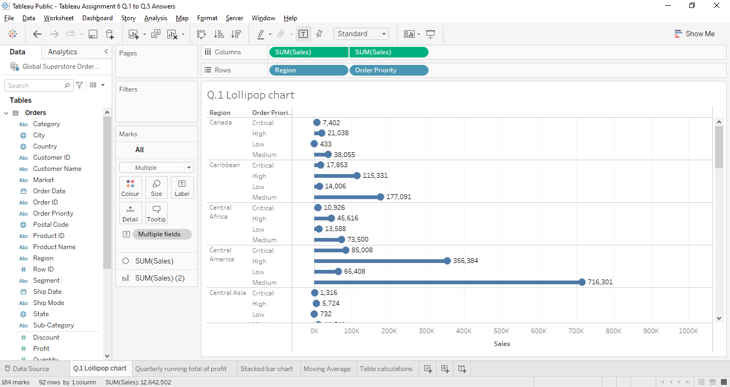

1. A running total is the sum of a series of numbers that would be modified each time a new value is added to the series. It is also known as "partial sum." Using the “Global Superstore Orders 2016.xls” dataset”, create a view showing the quarterly running total of profit for each “Market”. You may use the dimension Year(Order Date) used as a discrete dimension.

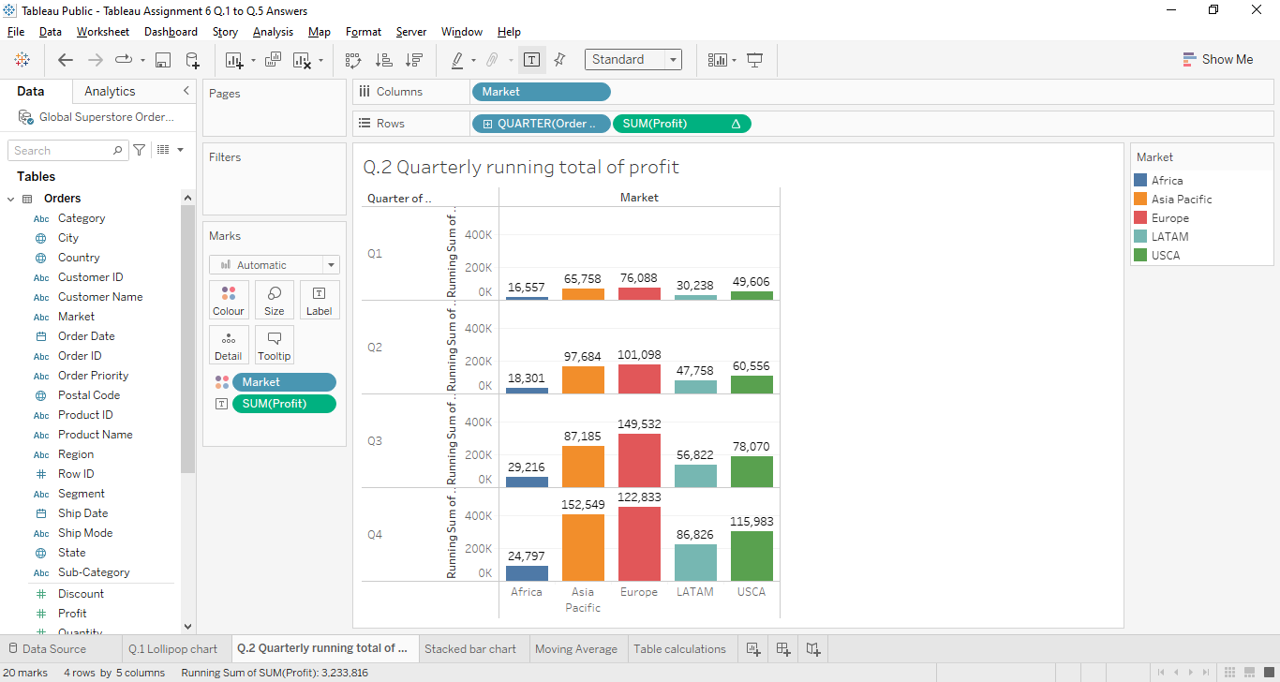

1. Percent distribution is another name for “percent of total” type of table calculation. Using a formula that divides a sum by the total, it is calculated. Example: By adding the numbers 250, 350, and 400 together, you can obtain the percent of the total for each of the following numbers: 250, 350, and 400 / (250+350+400 ) = 1000 is the total. To find the percentage for each, divide the sum by total: {[250/1000]*100}. Create a view using a stacked bar chart depicting the “Percent of Total Sales” for categories of products per segment per “Market” across several years. Write your key observations in terms of profitability of products across all the segments. Use the “Global Superstore Orders 2016.xls” dataset.

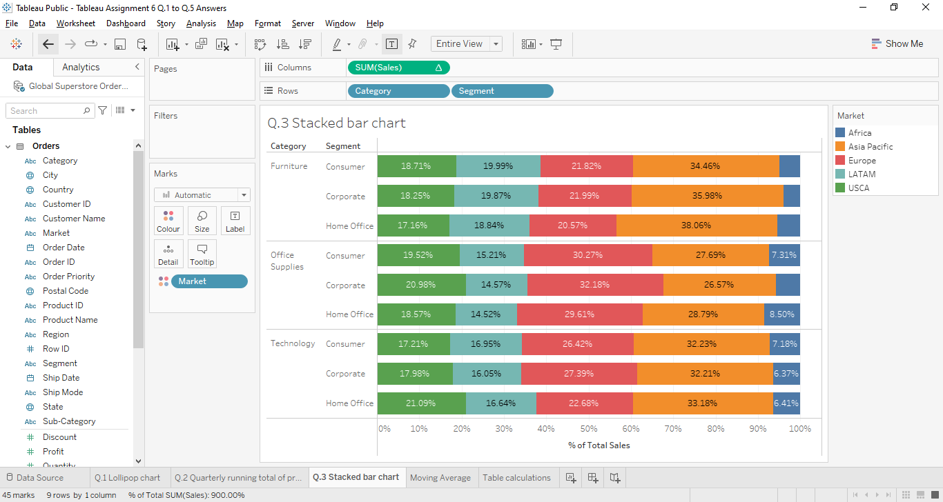

1. Demonstrate the use of “Moving Average” of the measure “Profit” across several years using the “Global Superstore Orders 2016.xls”. Use Month (Order Date) dimension represented as continuous data on columns shelf. Moving averages are considered lagging indicators. They are based on occurrences that have already taken place, and they are not predictive tools.

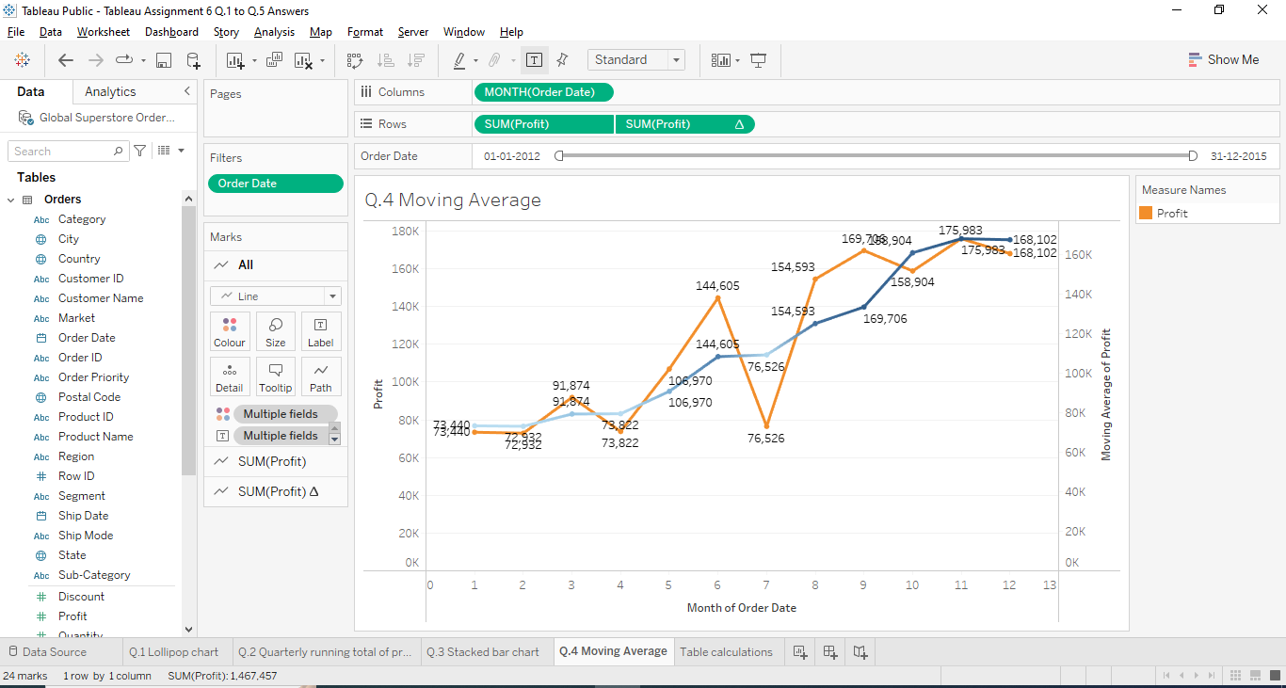

1. Create a view using the table calculations, depicting the rank of the "States" based on their “Sales”. The "States" with the highest sales are listed first, followed by the "States" with the second-highest sales, which is listed second, and so on. Use the “Global Superstore Orders 2016.xls” dataset.

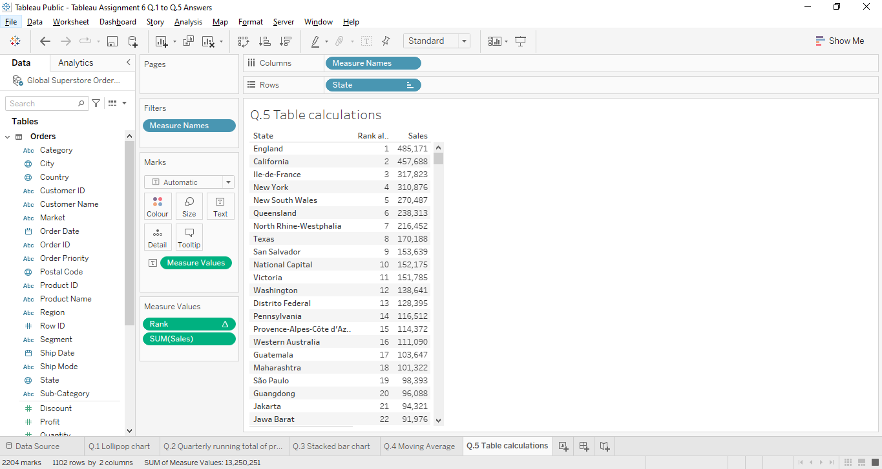

[*PFA links for the datasets used.*](https://drive.google.com/drive/folders/123UyMRbrReCjyn1K4g_FhsjKx6cP4zLH?usp=sharing)